Trading Experience Day 1

1. Stocks – Overall bank nifty and 43100 PE (down) and CE (uptrend) for alternate trend
2. Apps used – Tradingview to draw lines and patterns, Zerodha for adding options to watchlist
3. Trade type – Intraday 5 mins TF, options
4. Indicators - No
5. Strategy – Before 9, check SGX Nifty and it was good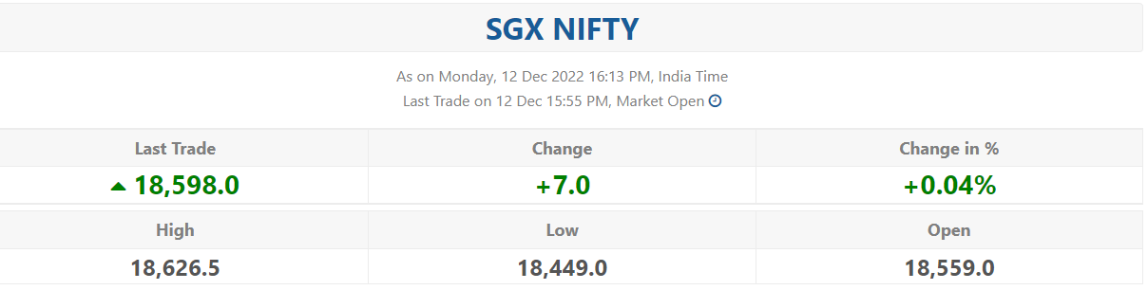
6. Market opens with small gap down- Used Gap Strategy- But it didn’t breakdown the previous day LOW

***Trading journey:***

1. After Market open, I was waiting for 1st 3 candles to complete and then I was looking for patterns, it’s a “Morning Star”, so there is a HIGH probability to go up

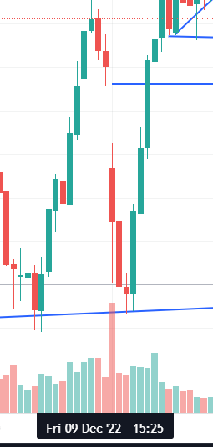

1. As shown above, it couldn’t be able to B/D the previous day LOW so retesting confirmed

AT this stage, I decided the market should go up, so I bought 43100 CE at 456rs and waited for the trend to cross the PDC

1. It crossed the previous day close as well, so I decided to keep that as a new support and PDH as a resistanceChart

   Description automatically generated
2. In Today’s market there are not much volatility after it cross the PDC line, throughout the day it was sideways, so I decided to find small trends and profits
3. Marked two exit levels and exited at the 2nd one for the day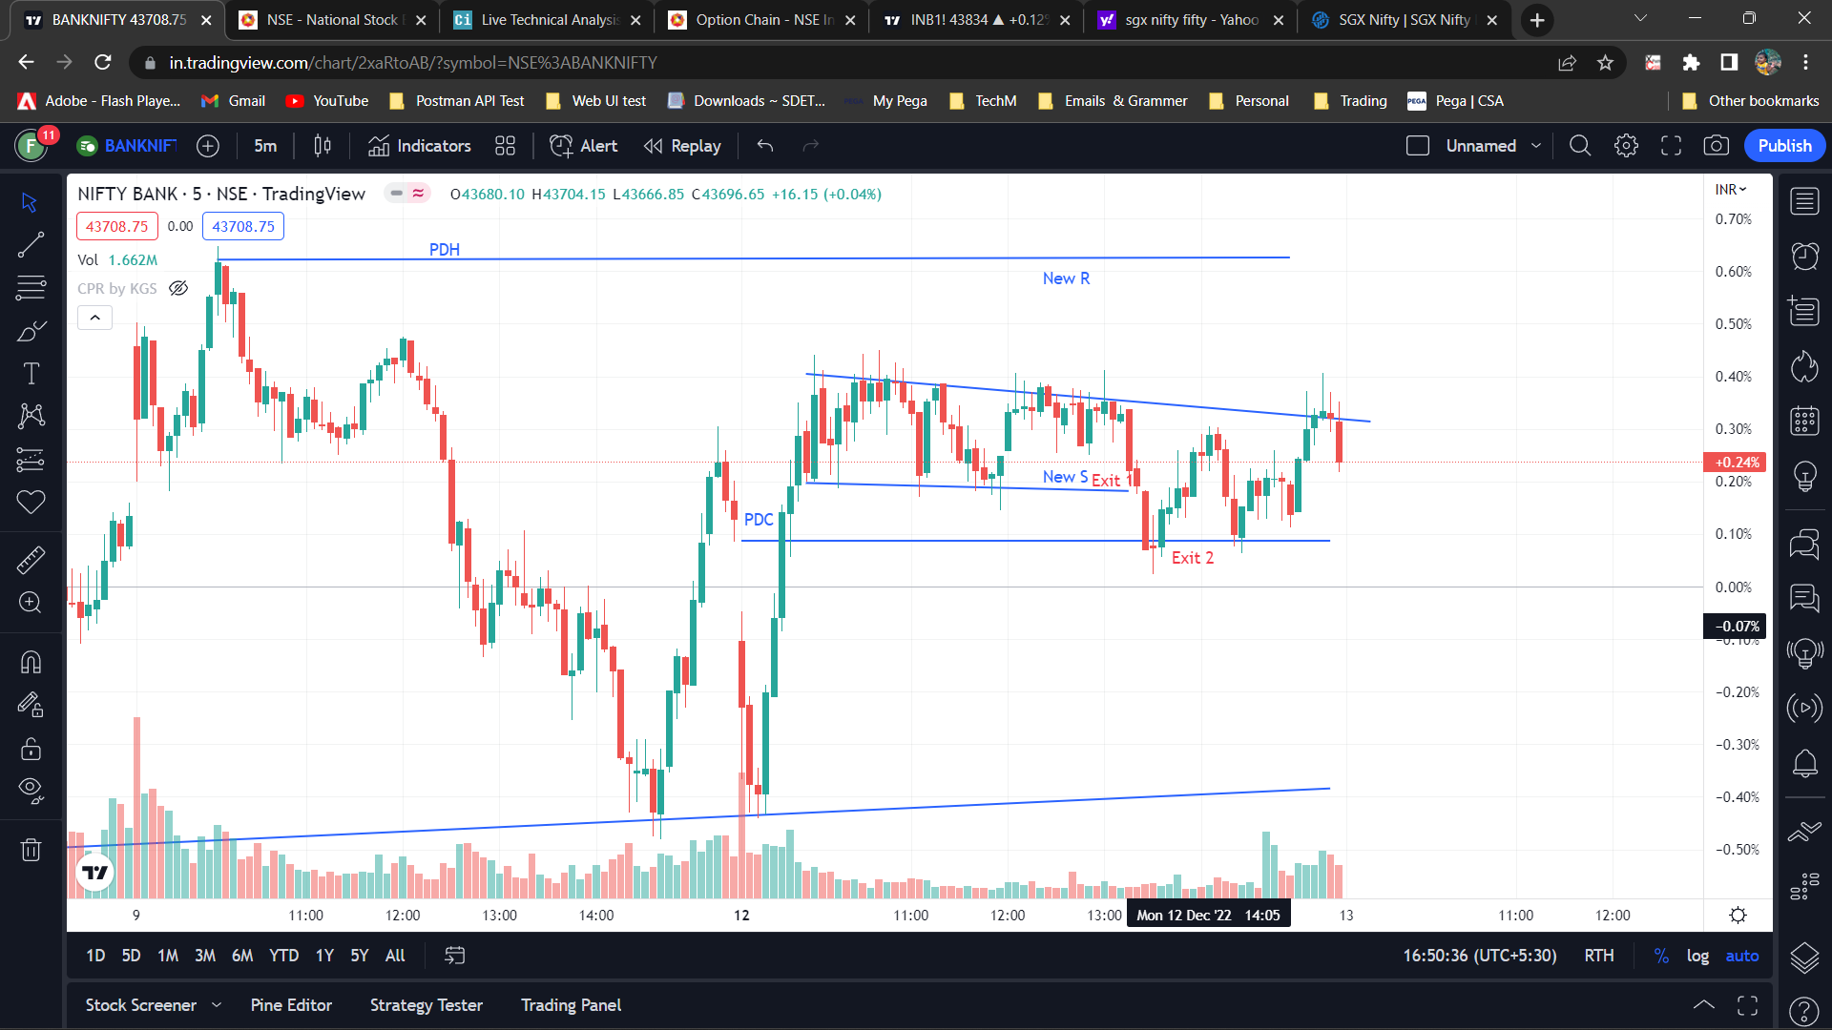
4. Total points earned for the day – 100 rs

***Final Diagram:***

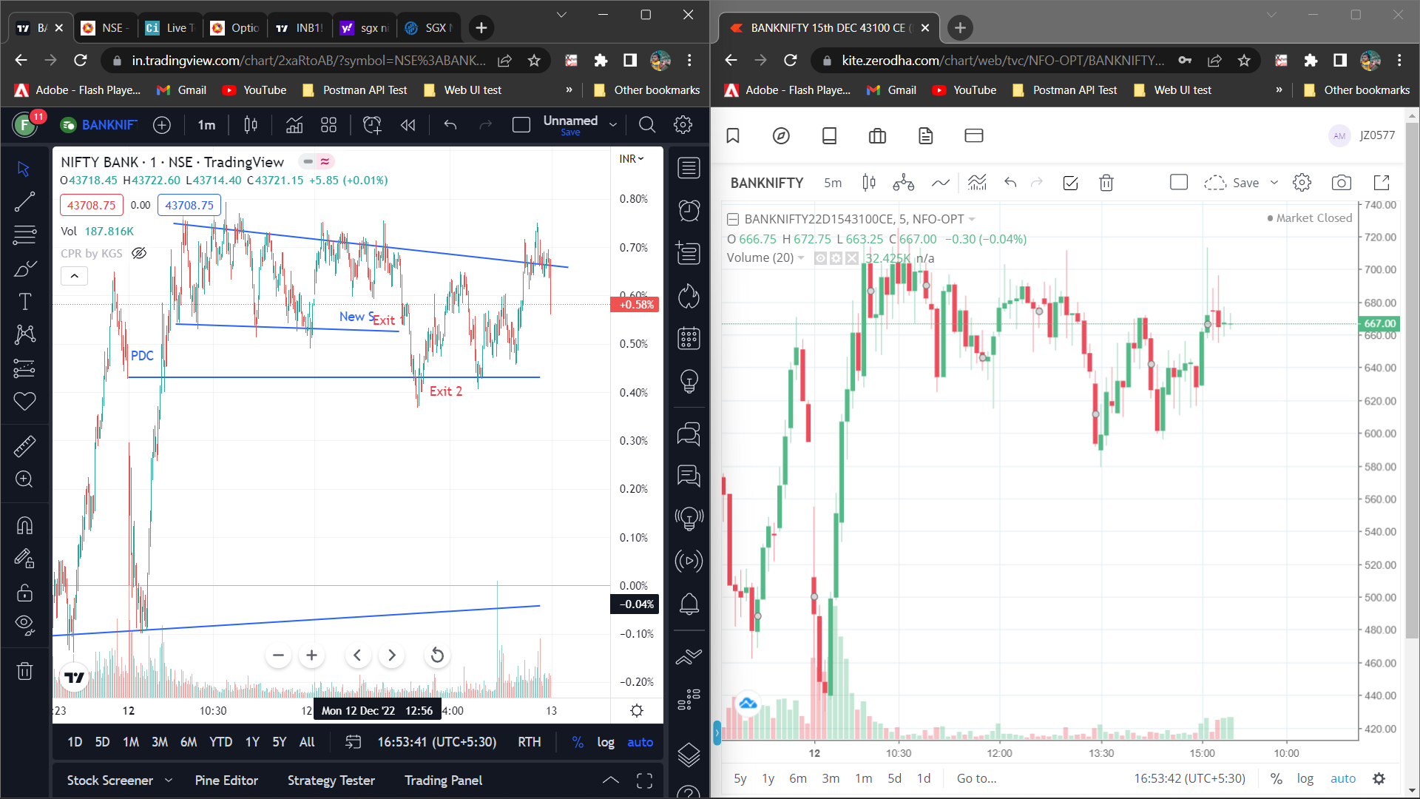

Post Trade I added few indicators to confirm the trend

1. CPR by KGS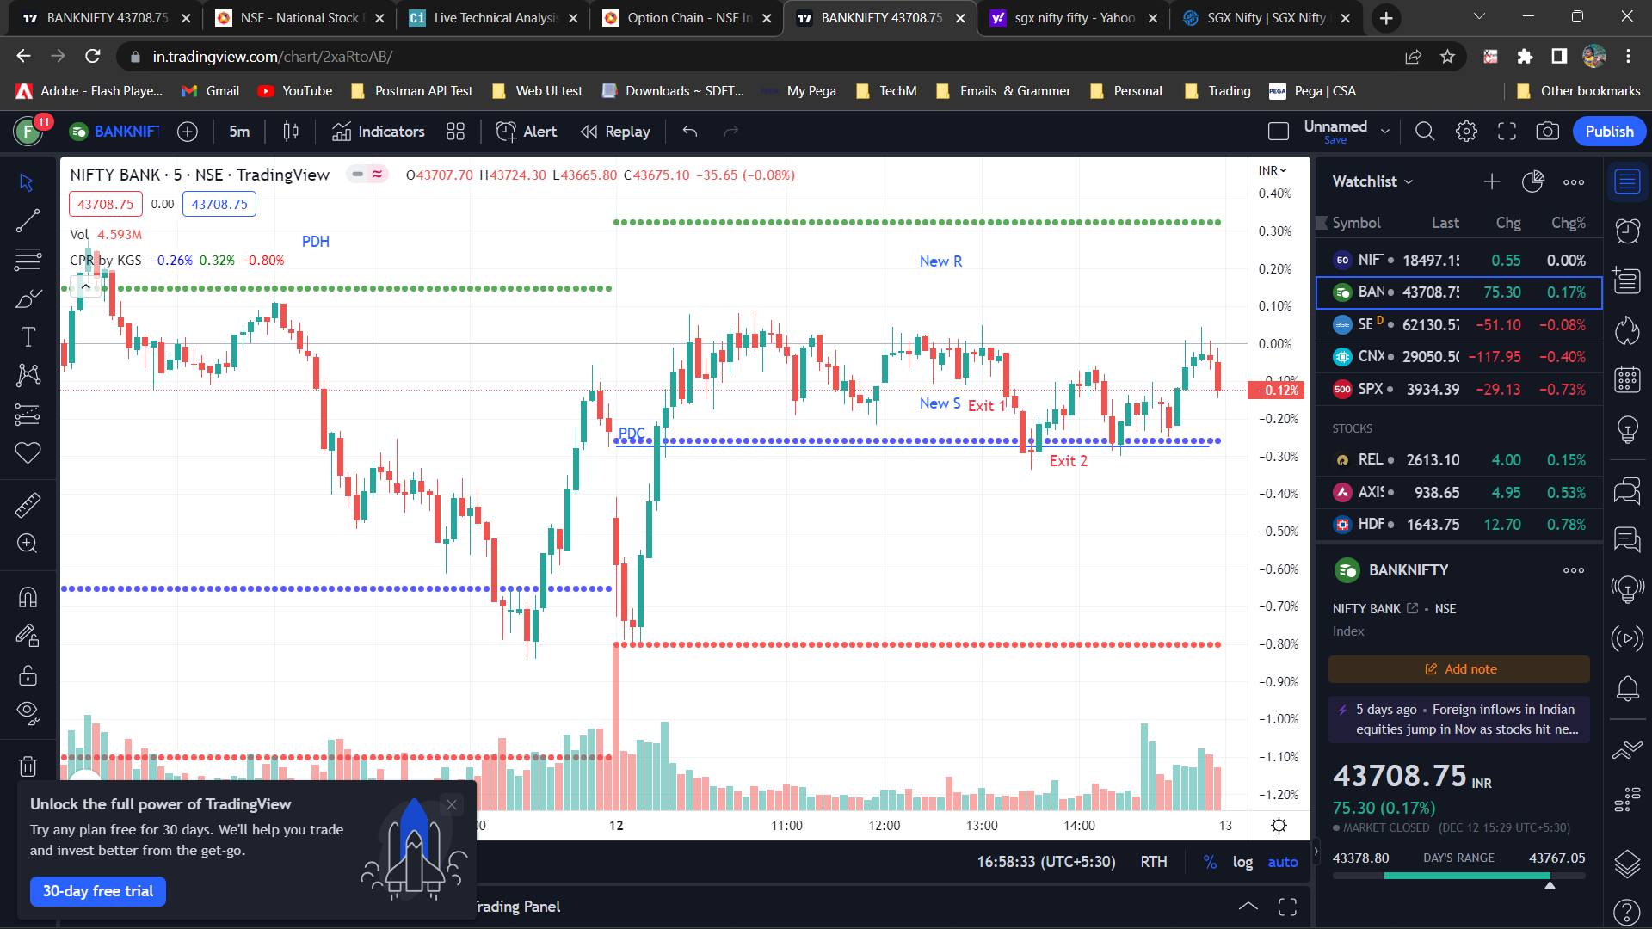
2. Need to add RSI to set SL next time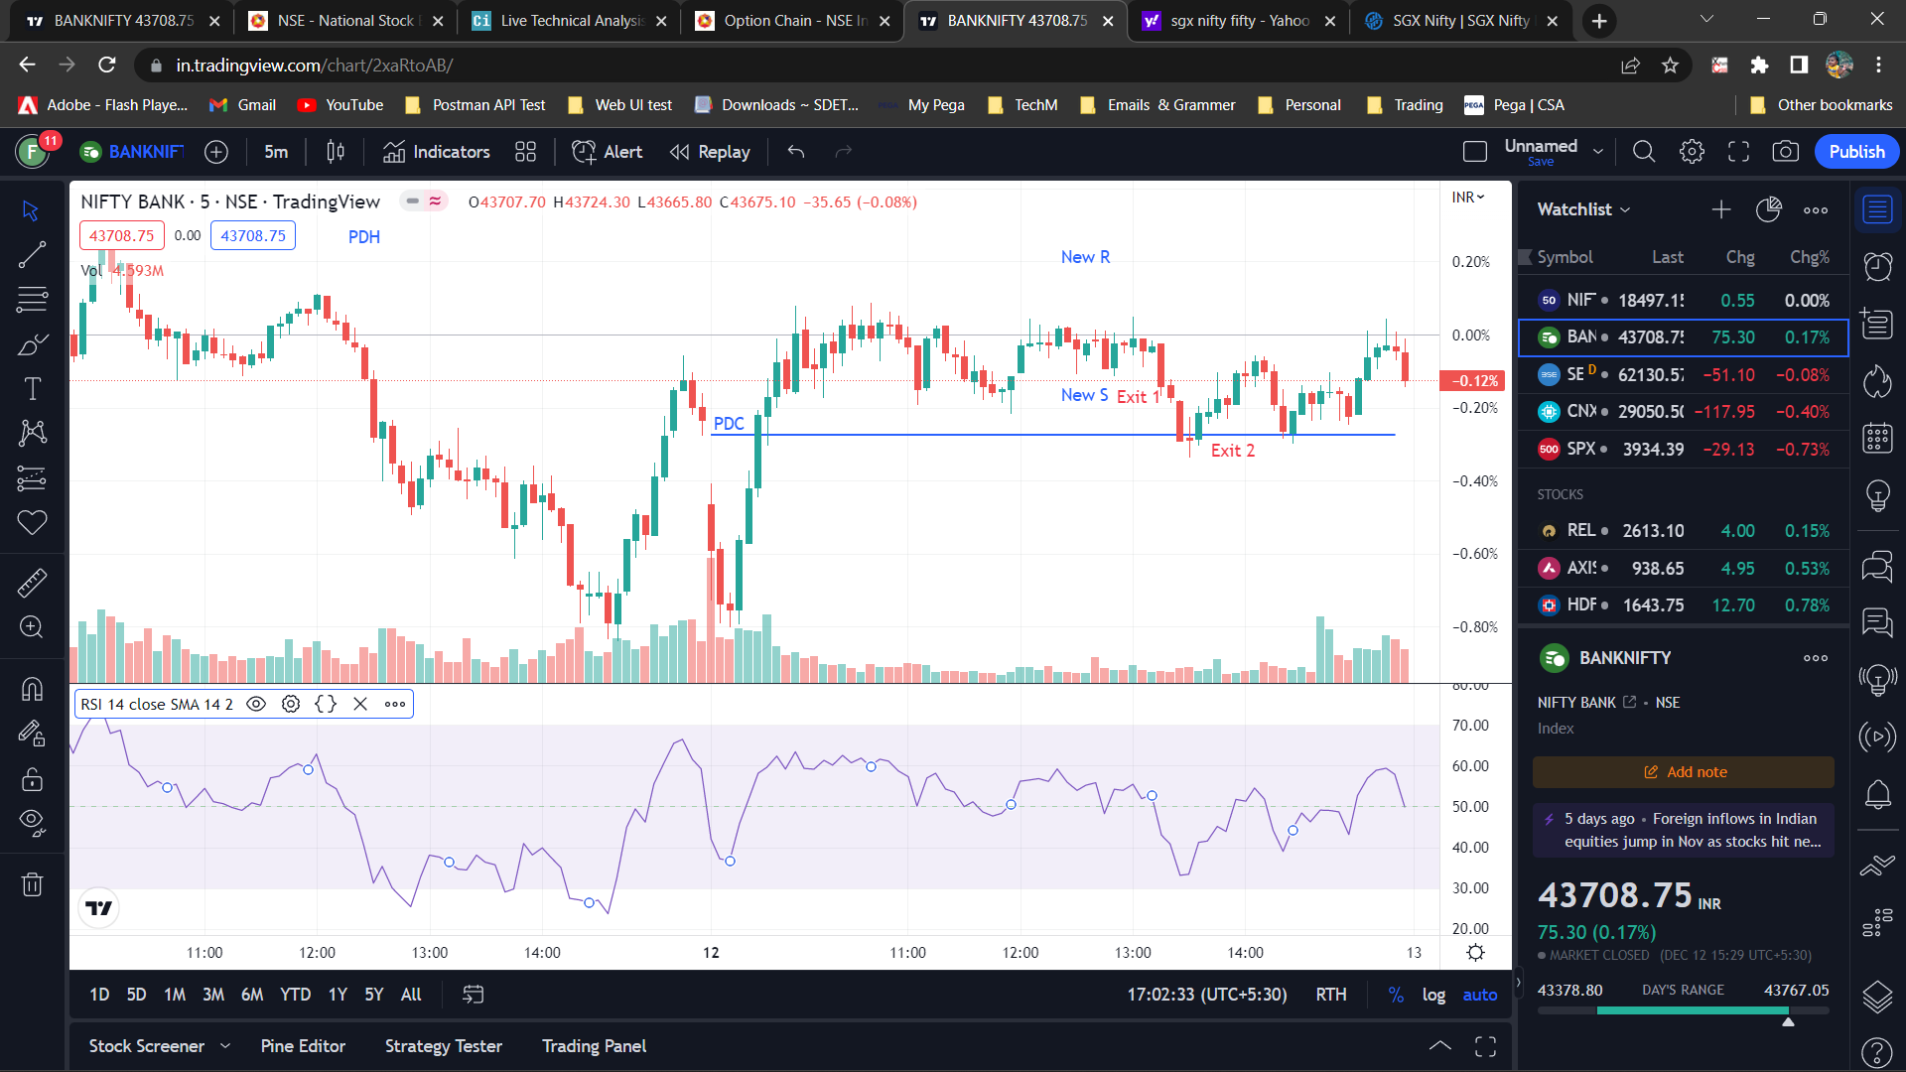
3. EMA 50